Healthy Smiles Plan

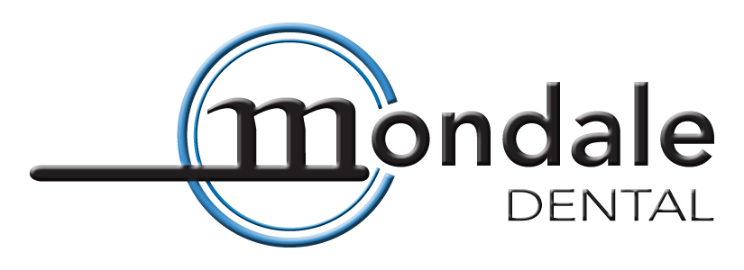

We created the healthy smiles program for people without dental benefits. We want to help you cut the cost of dental treatment without sacrificing the high caliber of care you deserve. Regular cleanings and dental exams safeguard the health of your mouth and your dental work like nothing else. When you purchase the Healthy Smiles Plan you are prepaying for a year of cleanings and exams. When you bundle your annual cleanings and exams we give you a big discount, and on top of that we will give you a 15% discount on all additional services for an entire year!

If you have looked into getting individual dental insurance you have probably seen that third party companies often have: high premiums, low payout, unusual waiting periods, and multiple limitations or loopholes as to which services are covered.

With the Healthy Smiles Plan you will find:
- No Deductibles
- No Claim Forms
- No Pre-Authorization Requirements
- No Pre-Existing Condition Limitations
- No Waiting Periods
- No Yearly Maximum (no limit on how much you can save)
- No LEAT Clauses (least expensive alternate treatment)
- Includes cosmetic services.

Get the excellent care that you expect from Mondale Dental and keep your smile as healthy as it can be with the Healthy Smiles Plan
Three plans are available to suit your needs, choose from a routine cleaning plan for regular preventative exams and cleanings or the periodontal maintenance plan for treatment of gum disease.

Periodontal Maintenance
$760
- 3 Periodontal Maintenance visits
- 3 exams
- 3 oral cancer screenings
- Routine diagnostic x-rays (does not include problem focused x-rays)
- 1 Fluoride Varnish or Cervitec treatment
- Periodontal examination
- 15% off of all services for an entire year!
* program includes first 3 periodontal maintenance visits if additional visits are recommended the 15% savings will of course apply to them.
Routine Cleanings
$480 Adult (age thirteen and up)
$405 Child (age twelve and under)
- 2 cleanings
- 2 exams
- 2 oral cancer screenings
- Routine diagnostic x-rays (does not include problem focused x-rays)
- 1 Fluoride Varnish or Cervitec treatment
- Periodontal examination
- 15% off of all services for an entire year!

Plan Guidelines
- All savings plan membership fees are due and payable in full at time of registration.
- To receive your 15% discount all payments are due the day of service.
- While the 15% discount expires one calendar year from the start date, you will be given up to one month past your membership year to fit in your final cleaning and exam.
- There is no refund for unused benefits, we recommend pre-appointing your cleanings to make sure you get them all within the covered period.
- Additional family members plan start date will begin on there next date of service at Mondale Dental (i.e. their next appointment).

Plan exclusions and limitations
- Plan benefits and discounts are non-transferable they apply to the covered individual only.
- 15% discount cannot be combined with any other discounts or offers.
- 15% discount cannot be used to purchase or renew a Healthy Smiles Plan.
- 15% discount does not apply to merchandise sold below MSRP.
- Savings plan members cannot use any other dental coverage with this plan.
- Healthy Smiles Plan will not apply to costs of dental care for injuries covered under workman’s compensation, casualty, or auto insurance claims.
- Covered benefits of the savings plan are available only at Mondale Dental.
- Discounts will not apply to any portion of services referred to specialists.

Sign me up today!
I would like to enroll myself into the Mondale Dental Healthy Smiles Plan for one year. I acknowledge that the Healthy Smiles Plan is a discount dental program through Mondale Dental and is not a registered dental insurance plan. I have read and understand the plan guidelines and the plan exclusions and limitations written above.

Name:________________________________________ Start Date:___________

I would also like to enroll the below listed family members.

Name:________________________________________ Start Date:___________

Name:________________________________________ Start Date:___________

Name:________________________________________ Start Date:___________

Signature person responsible for account : ________________________________ Date:_________

Roger Mondale, D.D.S. • Brian Mondale, D.D.S.
10600 Old County Road 15, Suite 120, Plymouth, MN 55441
Phone 763-512-8500 Fax 763-512-8592 mondaledental.com

